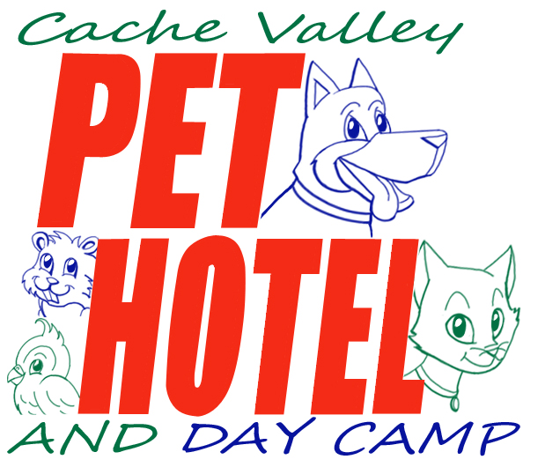

160 S 600 W LOGAN UT 84321
---------------------------------------------
cachevalleypethotel.com 435.755.5776

Feline Guest Information Sheet

Owner's Name: __________________________________ Date: _______________
Address: _______________________________ Phone(s): _______________ (H/W/C)
_________________________(City, State, Zip) _______________ (H/W/C)
E-mail: _______________________________________ _______________ (H/W/C)

Cat #1 Name:____________________ Age:_________ Birthday:____________ Sex:M/F
Breed:_________________________ Spayed/neutered: Y/N
Cat #2 Name:____________________ Age:_________ Birthday:____________ Sex:M/F
Breed:_________________________ Spayed/neutered: Y/N
Cat #3 Name:____________________ Age:_________ Birthday:____________ Sex:M/F
Breed:_________________________ Spayed/neutered: Y/N

Local emergency contact: __________________________________ Phone: ________________

Medical:
Veterinarian: Dr. __________________ at ____________________(clinic) Phone:____________

Do we need to administer any medications or injections? Y N
If “yes” please complete the Medication Release Form.
Please list any allergies your cat has: _________________________________________________

For Boarding:
If boarding more than one cat can they share the same cage initially together? Y N
Would you like your cat(s) to be “loose” in the cat room after the first day or so? Y N

We free-feed the cats that are allowed to stay “loose” in the cat room with owner-provided food and/or in-house food. Please let us know if this is a problem. We can feed them in cages if necessary.
We provide food at no charge but recommend you bring your own food to minimize the chance of digestive upset. Please describe container for any food brought:_____________________________
Any special feeding instructions: _____________________________________________________
If your cat(s) don't appear to be eating for more than a day, we will add soft food to their diet to try to get them to eat. Please let us know if this is a problem.

General Questions About Your Cat(s)

Has your cat shown any aggression toward humans? Y N
Kids? Y N
Other cats? Y N
(continued on reverse/next page)
If yes, please explain: ___________________________________________________
Does your cat get along with other animals in the house? Y N
If no, what are the circumstances? _________________________________________

Does your cat have any joint or muscle problems? Y N
If so, please list: _______________________________________________________

Does your cat have any restrictions to movement like running or climbing? Y N
If so, please list: _______________________________________________________
Has your cat traveled out of the country in the last 2 weeks? Y N
If so, where? ____________________________ Dates: _______________________
Has your cat been diagnosed with an upper respiratory infection in the past 2 months? Y N
Has your cat been sneezing today or the past week? Y N
Does your cat like to be brushed? Y N
Is your cat sensitive on any part of the body? Y N
If so, where? __________________________________________________________
Is your cat crate trained? Y N

Your Cat's Personality
Is your cat (circle one) scared shy/timid medium inquisitive bold
How is your cat with strangers? scared indifferent friendly
Is there any kind of people your cat prefers? men women no difference
Where does your cat stay when left at home? outside crate special room free run of house

Does your cat have problems with:
Using the litter box? Y N
Marking/spraying? Y N
Hiding and not coming out for strangers? Y N
Sharing his/her food with other cats in the house? Y N
Separation anxiety? Y N
Escaping out doors as they are opened? Y N

What kinds of things does your cat like? (circle all that apply)
motorized toys “batting” toys dangling toys scratching posts/pads

We use water squirt bottles and “NO!” to stop undesirable behavior. Please let us know if this is a problem.

Is there any other information about your cat(s) that we should know? ______________________
_______________________________________________________________________________
_______________________________________________________________________________

How did you hear about the Cache Valley Pet Hotel and Day Camp? ________________________

